**Dark Times**

**“Light the way”**

**high concept:**

Dark Times is primarily a turn based tactical RPG set in a medieval fantasy world. You will design your own character that will be placed as the leader of a newly founded organization set up to exterminate otherworldly threats. As the leader you will have to manage the “venators” group, sending members out on missions, managing resources, overseeing or taking part in battles but most importantly keeping yourself alive.

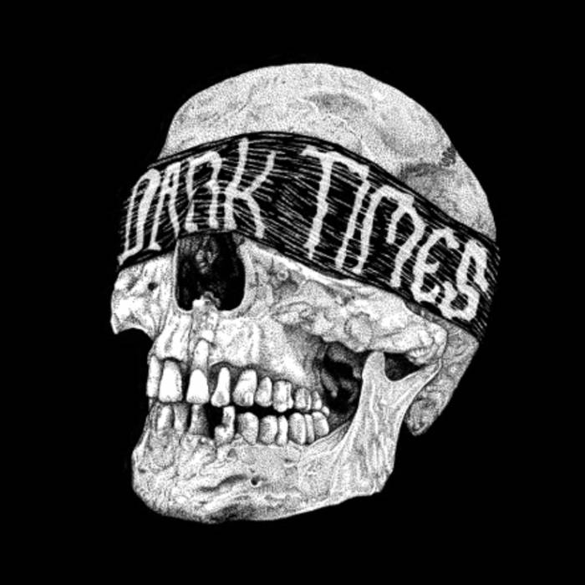

**Pitch:**

War is a constant throughout Aguaria’s history never has there been true peace, but now a greater darkness approaches, vile creatures roam the land, arcane fire burns villages to ashes and yet the kingdoms do nothing, preferring their petty squabbles and quaint rivalries. There is only so much time left, action must be taken soon before all is consumed, will anyone be able to light the way in these dark times?

Dark Times is primarily a turn based tactical RPG set in a dark and gritty medieval fantasy world. You will design your own character that will be placed as the leader of the newly founded organization “venator” set up to exterminate the rapidly increasing amount of otherworldly threats facing the continent of Aguaria. As the leader you will have to manage the “venators” group, sending members out on missions, managing resources, overseeing or taking part in battles but most importantly keeping yourself alive throughout it all.

This game will have three main gameplay aspects the first will more central part will be the turn-based combat and the second base/character management and the final is your own character management. The Turn-Based combat will use a 3rd person godlike view to merge turn-based combat using tiles with smooth animations and combat sequences to give players a fun and tactical experience. The Base/Character management section will allow for players to view their encampment and build new building with resources gathered throughout the game. This will allow for new missions/classes/abilities/equipment and more as well as this it will allow players to recruit, customize and manage members of “venator”. This screen will also hold the main hub that will track requests/missions/events/information about the kingdoms and other information about the state of the game. Finally managing your own character plays an important part in this game, like other characters he can be sent on missions, learn new abilities/traits. However, if your character dies the game will end, as the game is played through your character, so careful management of your character is crucially important.

**Story:**

Player Character Backstory:

(The player character’s name and gender can vary depending on selection during character creation. For this I will use a male by the name Merek Terrowin).

Merek Terrowin was born the only son of Fender Terrowin and Alianor Terrowin. Tragically his mother, Alianor, passed away during child birth. His father Fender was marked as a heretic for studying dark magic by the church shortly before the birth of Maraek. He explained to his son that they feared what they did not understand and his goal was to use this magic to help expand people’s life spans. This caused Merek to spend much of his early life constantly traveling with his father to avoid the churches agents.

After some time, they settle in the small village of Terryn, so that Fender would be able to conduct more experiments towards his goal. Merek became friends with his father’s new assistant, a local girl called Ayleth. However, disaster struck when Ayleth became an undead after she drank a potion, intending for it to prove that Fender research would save the world. The undead infection quickly spread, overrunning the village. Exorcists from the church and other paid mercenaries quickly arrived at the scene. Merek was the one of the few survivors of the 'cleansing', saved by Gerard Ulric, a mercenary who wanted information on those responsible.

Heading to an emergency meeting point just outside the village set by his father, Merek confronted his father on his research and Ayleth’s death. Fender explained that he wanted to live forever and would do anything to obtain this goal for himself and Merek. Enraged by the fact that his farther shows no remorse for the dead and the fact he may continue his research elsewhere, Merek stabs his father to death with a dagger when his back is turned.

After this traumatic experience he returned to the remains of the village, with nowhere to go he asks his saviour, Gerard Ulric, if he could travel with him and learn from him to becom stronger so he can fight for those who can’t fight for themselves. Taking pity on the boy Gerard Ulric agreed and the two spent their next year’s training, traveling and helping those in need.

As Merek grew older he noticed how little impact just the two of them were having on the grand scheme of things, so they decided to set up an organization to help battle the increasing number of threats to Aguaria. Using the funds, they had made from there mercenary work across the land they set up the organization with like-minded individuals they found on their travels. Gerard Ulric has started to grow old so decides to take a back seat and let Merek run the group the called “Venator” although he still provides support for Merek and helps manage the group in his absence.

Narrative:

The Story follows that of the group “venator” through the perspective of your character. The game starts with the recent formation of the group “venator”, from here the main aim will be to start building up the group while making sure to try and keep the forces of darkness at bay. The main story line will follow a mission line that will have the players try and identify the reason for the increasing number of monsters throughout the land. It will begin with some investigations into strange happenings and large increases of monsters in certain areas. After some fruitless searching the player will stumble upon a cult that will act as the overarching enemies of the story. The quest line will then follow you trying to find out more about the cult and trying to dismantle it. This will finally lead to a confrontation with the leaders of the cult where you will discover than the cult is secretly being led by a daemon in disguise. The final battle of the main questline takes place where the hero must defeat the cult and its daemon leader and put an end to the increasing number of monsters plaguing the land.

Throughout the game there will also be many different events, while these events are not part of the main quest line, they will have substantial effect on the game. One example would be two kingdoms declaring war on each other, you can choose to get involved to try and help one kingdom or you can just try and ignore the war completely. Each has its own benefits and repercussions and can affect your priorities in the game.

NPC Backstory:

Gerard Ulric is the only main NPC, He spent his early years training with his farther who was also a mercenary, following in his footsteps he became a traveling mercenary with a soft spot for helping those in need. He never settled down and was always on the move one place to the next, until one day on an extermination mission he ran into the PC and decided to take you under his wing. Growing old he decided to take a back seat in you group but is willing to help manage the group in your absence. Throughout the game he will give you advice and tips that can come in useful and help you better understand the game.

As there is little dialog between characters throughout the game there are not many NPC characters that need to have a substantial backstory. For example, all enemies will have a short bio but as they do not interact in any way other than in battle there is no need for large backstories for enemies. Similar to this if each ally had its own backstory the game would get to cluttered as the player will have control over large amount of characters, especially towards the end of the game.

**Look & Feel:**

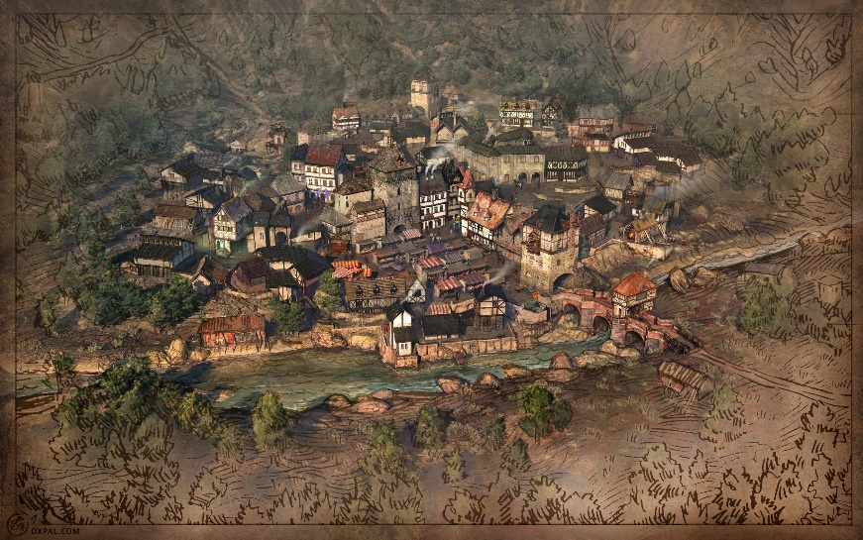Dark Times has two main aspects of gameplay however both use the same look and feel so to keep the game consistent and so that the transitions between gameplay elements is smooth. They both use a 3rd person godlike view to show a realistic dark and gritty medieval fantasy world. A 3rd person godlike view is being implemented in both the gameplay elements as it allows players to better view the battle fields while still allowing for more complex player models and animations. The game will use a dark, realistic art style to better fit the theme and tone of the game, having light vibrant colours and a more cartoon like art style may put some players off the game as it does not fit the dark and serious tone set by the game and its missions.

For the base management section of the game the screen will show a zoomed-out map of your current encampment. At the beginning of the game this will start quite small with few buildings and as the game progresses more can be built. You will be able to zoom and move the camera around, which will come in handy once you start expanding your base. All the buildings will have a medieval style with brighter colours than the turn-based combat, giving players a more relaxing feeling when managing their base.

For the turn-based combat section of the game the player will have a less zoomed out screen and the map will be subtly be spilt into tiles. These tiles can however only be seen when a unit is selected, this is done so that It does not get in the way of the aesthetic of the game however appears when it is needed for movement of units. This screen will show the 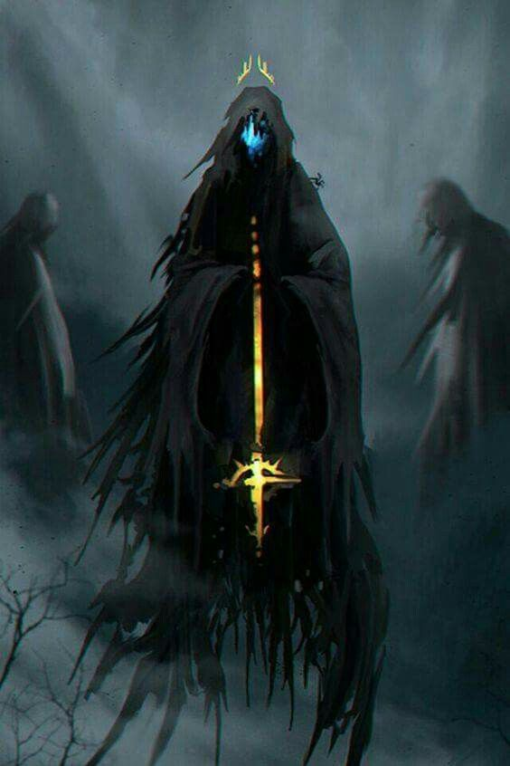environment of your current battle, your units and the NPC units. The maps will stick to a dark medieval fantasy theme, having maps such as dark forests, ruinous castles etc. The enemies will also have a realistic and dark appearance trying to give the player a feeling of how intimidating it would be to face them in battle.

When playing this game, the player should have a sense of urgency and dread, as such it is important that sounds, such as music are incorporated in a dramatic way during fight scenes or when the game is close to being over. The art style should not take away from this and should make the player feel on edge during the battles, this can be done by using darker imagery from having objects such as dead bodies littering the map to just having a dark atmosphere to the map itself (such as a graveyard) as well as having intimidating enemies.

**Interface:**

There are two separate interfaces for each aspect of the gameplay:

Base management: The main part of the screen will show your medieval base (similar to the picture in the look and feel section), however along the top left of the screen will be a strip displaying resources using icons and numbers, this will allow players to easily see what resources they have making it easier to decide what to spend them on. Along the left of the screen will be a list of existing buildings, by clicking on these icons or the buildings themselves you will be taken to a menu that will show you what the building is for, and will allow you to use the building for its purpose e.g. buy armour upgrades at the blacksmith or managing your characters at the barracks. Towards the top right of the screen will be important trackers, such as the darkness tracker which you can use to monitor how long you have to evil overruns Aguaria.

turn-based combat: During the combat section the information about the mission, possible enemies and numbers will be shown in the top tight hand corner along with any dialog. The turn counter as well as information on whose turn it is will be at the top of the screen. Along the left will be a list of all your characters, their health and action points remaining that round (this is also shown above each of the characters models. However, showing it on the left allows the player to more easily access this information if his units are spread out). Along the bottom of the screen will be a list of possible actions for each character when selected, this is used to select what you want each character to do that turn.

The games interface is somewhat comparable to other games of this genre of turn based game. To help give a better example of what it may look like, bearing in mind the differences from the image to what I explained above, I have taken an image from another turn-based game called phantom doctrine. 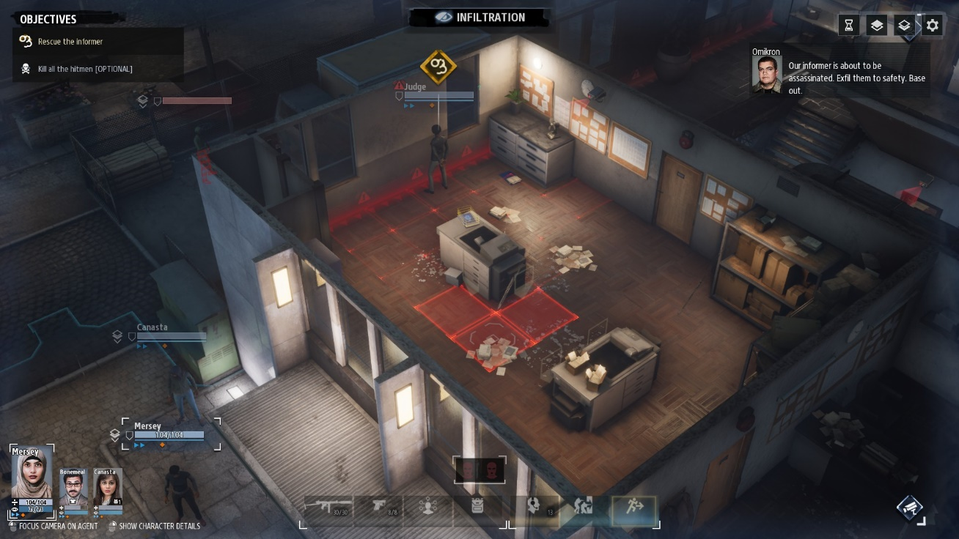

Round Information

Dialog

Possible actions

objectives

characters

Keyboard and mouse bindings:

Complete action e.g. movement

Quick save

Select unit/building/upgrade

Rotate camera (q/e)

Pan camera (w/a/s/d)

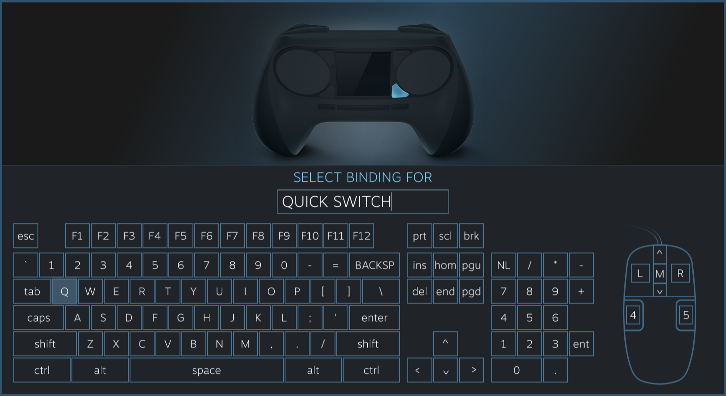

zoom

Next unit/building

Confirm action

**Start-Up:**

After the tutorial ends the player is taken to the management screen, from here he will be able to see the starting buildings (Headquarters and Barracks, as well as available points to build new buildings when requirements for their construction are met.) You will also be able to see the current resources of the organization, reputation, as well as relationships with the kingdoms and finally the tracker for the time until the monsters overwhelm “Aguaria”. For now, the players can use this screen to access the barracks to recruit, customize and manage members of “venator”. The Headquarters to look at missions/tasks/requests and progress time or start building some buildings such as the blacksmith. Once the player has had enough of customizing or building up the base, they should either start taking on missions or just pass time. Passing time will gather resources and may give new missions or quests, however time sensitive missions may disappear if not done in time. The missions will usually involve combat so taking these will lead to the Turn-Based combat portion of the game. In this section players will have to select available members to send on the mission, once this is done the missions will begin placing the player in a 3rd person godlike view with control over his units. Depending on the mission you will have to use your units in this tile-based system to find and eliminate any enemies using attacks/spells suited to each character’s customization.

**Objectives:**

The main objective of the game is to stop the tide of monsters that are swarming “Aguaria”. To do this the player must find the source of the increasing number of monsters and put an end to the encroaching darkness. This is done by following and completing the main quest line which at its end see’s you defeat a dark evil and halt the encroaching darkness. However, while the main quest is important to ending the game you can also lose the game if the “darkness” tracker (a tracker for the time until the monsters overwhelm “Aguaria”) reaches full. The tracker starts by increasing every day by 1 point towards 50 but as the game goes on this speed will ramp up. When 50 is reached the game ends as the monsters have overwhelmed the remains of “Aguaria”, however you can reduce the amount of “darkness” points by completing missions/quests so it is important to complete these as well as the main quest if you are going to last long enough to play through the main quest line.

Some sub-goals would be:

To increase the “Venator’s” reputation by successfully completing quests and missions this will increase the amount of quests and missions you receive allowing for more opportunities and choice when selecting missions. However, failing missions will also decrease reputation.

Building good relations with the kingdoms by completing quests/missions/events for them will help you get there backing. Thus, they may give you more resources or man-power to help with stopping the encroaching darkness.

Building up your base will also allow for better upgrades, equipment, new sub classes, skills and traits. However, building new buildings takes time so be carefully when making a lengthy investment.

**Tokens:**

**Characters:** The characters you control make up a large part of the game so it is important that you have a lot of customizations over them. As such the as the characters level up and progress you will have control over what path they take, what skills they will learn and how they will contribute to ending the darkness. Also, as you design your own character which the game is played through it is important you have full customization over him/her allowing you to edit the character to your liking.

Your own character is very important as the game is set up to be played through him/her as such if he/she is killed then the game also ends in a loss.

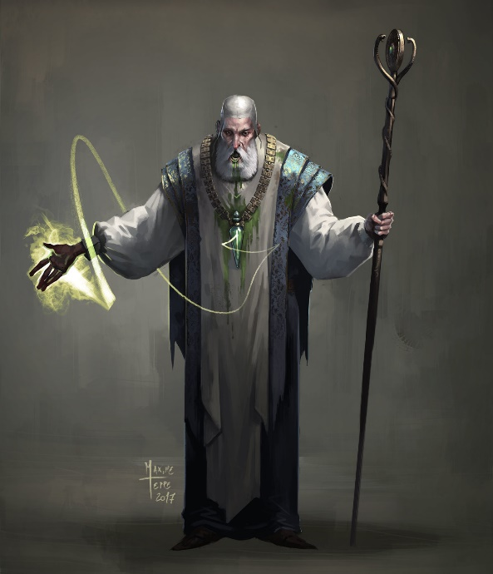Stats: All characters will have the Strength, endurance dexterity and willpower stats. Each of these effects an aspect of gameplay and will differentiate the characters form each other. You can fully customize your own stats at the start, however other characters can only be will start with randomized stats (within reason) to simulate how all people are different and do not necessarily fit exactly what you want but you can then help them grow to your choosing.

Strength – Used to help add to characters damage

Endurance – Used to calculate characters Health

Dexterity – Used to calculate movement and accuracy.

Willpower – Used for resolve tests (see if they retreat/run/panic) and more magical aspects later on

Classes: There will be 4 main starting classes each with there own skills/feats and bonus as well as drawbacks. However more sub classes will be unlocked as the game progresses allowing for characters to diverge into different sub classes if they choose to.

Main Classes:

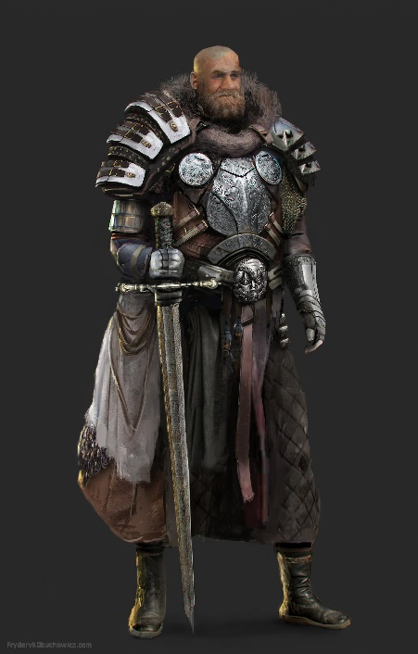Knight

Ranger

Assassin

Support

Sub Classes:

Magic user

Cleric

Exorcist

Etc.

Skills/feats/other: As the game progresses and characters level up, they will gain new abilities based on their classes, accomplishments and other such factors such as missions.

**Buildings:** There will be many constructible buildings that can be built throughout the game that each have their own bonuses. Some example of buildings that you start with or can build are:

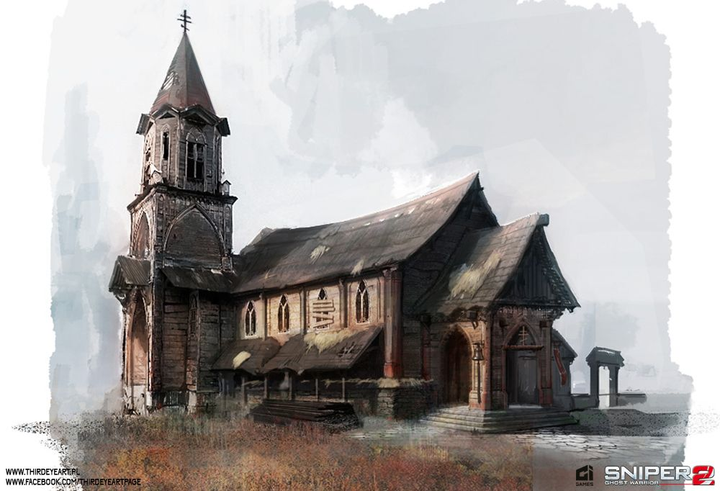Headquarters – Building that missions and events are handled from.

Barracks – Character management building.

Blacksmith – Used to build items.

Church – Unlocks Cleric and exorcist training and skills.

Market – Allows trading of resources.

**Trackers and resources:**

Time: This will show how many days in you are and the time in that day. Time can be skipped so this is an important way of keeping track of timed quests and missions. Characters will also take time traveling to and from quests during this time they are unavailable.

Darkness Tracker: This is a tracker in the management screen that tracks the progress towards the end of the game. It starts empty but fills by one point per day up to 50. If it reaches 50 the game ends.

Reputation: This shows your group reputation, the higher the more quests and better rewards you will get. Failing or not accepting some quests will lower your reputation and completing quests will raise it.

Relationships: Will show the relationships with the kingdoms of the land. Having good relations with the kingdoms will cause them to give your more missions, as well as this they will help fund your group and may give you more manpower if relations are good enough. Relations change based on your actions through the game such as completing quests, event decisions and other relationships with other nations.

Resources: These are the resources that will be needed to make new buildings and craft gear. They can be gained through completing quests, buildings or the market (once it is set up). The main resources are Gold, Iron, Leather, stone.

**Environments:** There will be many different types of environments that will be needed for the different areas for battle. Having different areas that are not too similar is important as it makes the missions more diverse and helps reduce repetition in missions.

Some example environments could be:

Ruined church

Graveyard

Dark Forest

Wheat Fields

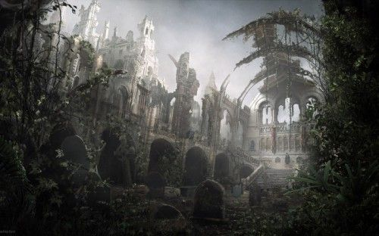Old Castle

Derelict Mansion

**NPCs:** The NPC’s will all be enemies that you fight in the turn-based combat section of the game. There will be different enemy types with different traits and preferences in battle. An example of this would be an Ogre is likely to charge without care for cover where as a cultist may use cover to his advantage. Some more examples could be:

Goblins

Daemons

Undead

Liches

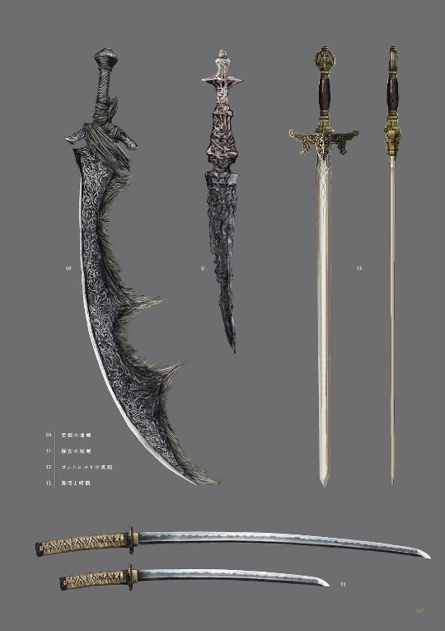**Gear/Loot:** Through the game you will earn loot and better gear these can be equipped onto your characters to improve them or used in ways to improve relations, improve your base or more. Some examples of loot could be:

Iron armour

Ring of fortitude

Thorn armour

Staff of fire

Gold

**Missions:** Throughout the game there will be different missions and events that impact the game leading towards its end. Completing certain missions will help stave of the monsters where as others may just gain you favour or resources. It is important to manage missions well as they are the key element in the game and lead to the turn-based battles.

**Rules:**

1. When the game reaches 50 on the darkness tracker the game ends in a loss for the player.
2. If your character Dies on a mission or during an event the game ends in a loss.
3. By completing missions, you will gain loot, resources, reputation and possibly relationship gains. However, failing missions will mean you miss out or lose these things.
4. You can fully customize your characters, and can customize other members of “Venator” as the game progresses although they will have set randomized stats at the start.
5. The different Buildings in the game will require resources and take time to build.
6. Any character is killed in battle when its hit points drop to 0 (applies for NPC and PC).
7. Characters will take time to travel to different destinations on the map.
8. Taking damage may lead PC to have injuries and have to heal and rest before they can be sent back out again.
9. PC characters and NPC will take turns fighting each other in the battle and the first to lose all their units loses the battle.
10. Units can retreat from the battle if the return to the point at which the mission started.
11. Different units will have different stats effecting that individual units, damage, accuracy, movement, health and more.
12. You can send different members to different missions at the same time.

**Features:**

Strategic combat: You will face tactical turn-based combat where you have to carefully mange you squad to complete missions while trying to take minimum casualties. However sometimes a mission may be beyond your capabilities so retreat is always an option for the less brave hearted.

Your character: You will have full customization over your character at the start of the game allowing you to build your own character the way you want. You will have control over appearance, stats, staring class and more. However, there is a greater importance to your character, if your own character dies the game ends in defeat. As such it Is important to carefully manage your own character as he leads the “Venator” group.

Base Building/management: You will have a wide range of building and expansion options that will open up new ways to play the game, such as adding new classes. However, these building cost valuable resources and a good deal of time. So, it is important to choose your buildings wisely.

Character Customization: Recruit, customize and grow unique characters by having full control over what attributes, skills, classes they will learn as they progress.

Large Scale threat: Your team will have to engage in multiple missions across “Aguaria” that will take time to travel to so it is important you carefully manage your characters planning ahead for the time they will be away.

Mission Management: You will have to carefully manage missions to build reputation, relations, gain resources and slow the darkness tracker. You may not be able to take every mission so it is important to take those you deem as important.

**Pay-Off Grid:**

In this example of a pay-off grid a knight class character is fighting a Werewolf and they both intend not to move away from each other.

It is the knight turn and has the choice of using strike, power attack or defensive stance.

Strike: Does 3 damage

Power attack: Does 6 damage but takes 3 damage this turn

Defensive stance: Takes half damage and does 2 damage to attacker

The Werewolf has its go second and can use claw, bite or evade.

Claw: Does 4 damage

Bite: Does 6 damage but takes 3 damage in return

Lick wounds: heal 2 damage sustained this turn

This shows the pay-off grid for the Knight based on the amount of health they would lose or gain in comparison to the Werewolf.

|  |  |  |  |
| --- | --- | --- | --- |
|  | Strike | Power attack | Defensive stance |
| Claw: | -1 | -1 | 0 |
| Bite: | 0 | 0 | 2 |
| Lick wounds: | 1 | 1 | -2 |

This is quite a simple pay off grid as there was only a small amount of options to choose from for each combatant as well as their only being two combatants. Later in this game the amount of new skill/attacks will greatly increase the size of the Pay-off grids as well as normally more than two characters would be fighting at once thus meaning either more grids would be needed to simulate the combatants or it would need to be greatly extended.

As you can see this grid is relatively balanced, this will not always be the case as the game will often have stronger or weaker enemies to face based of difficulty of the mission. If the user selects a too difficult or easy mission, they may find themselves with quite an unbalanced tree as enemies will either be much weaker/stronger than your squad of characters.

**Decision Tree:**

For this decision tree we will be looking at a ranger battling a cultist in a derelict church. It is the players turn as the NCP just had its turn and just moved into vision of the player character.

The ranger stays where he is and fires at the cultist.

The Cultist moves into the open in line of sight of the ranger.

Player 1 Moves into cover then fires his bow at the cultist.

The Ranger is in the Open, the cultist is low on life

The Ranger is In Cover, the cultist is low on life

The cultist moves into a flanking, covered position and attacks

The cultist moves to cover and attacks

The cultist Stays still and attacks

The cultist is in cover and flanking. Both characters are low on life.

The cultist moves to cover and the attack hit the rangers cover. The cultist is low on life.

The cultist stays where he is and the attack hit the rangers cover. The cultist is low on life.

The ranger moves into a flanking, covered position and attacks

The ranger stays still and attacks

The ranger moves into cover and attacks.

The Ranger stays still and his attack hits the cultists cover. Both characters are low on life. The cultist is in cover and flanking the ranger.

The ranger and cultist are in cover. The attack misses. Both characters are low on life.

The cultist Is Dead. The ranger survives the encounter on low life.

This is a very simplified decision tree as I have limited the number of different actions the ranger and cultist could take. In the actual game there would be far more options such as hunkering down, or using skills unique to the character. This also does not take into the account of probability to hit and assumes that the advantage of cover is enough to block the damage from range attacks, in the actual game it is possible to miss whether characters are in or out of cover and vice versa. I have used min-max in this tree to select the most efficient strategy to be taken by the player or AI on their respective turns.

**Gameplay in Words:**

**Base/character Management:** In this part of the game players will be able to view their base from a 3rd person godlike view, as well as have important information such as resources and trackers shown at the top of the screen. From this view the player can build new building with resources gathered throughout the game on areas of empty land, these new buildings will allow for new missions/classes/abilities/equipment and more as well as this it will allow players to recruit, customize and manage members of “venator” through the barracks building. This screen will also hold the main hub (HQ) that will track requests/missions/events/information about the kingdoms and other information about the state of the game. To complete the game, you will need to undertake missions, you will have to select some of the available missions from the HQ and select the members you want to send to complete the mission. Once selected the characters will travel to the mission site and when they arrive you will be given an alert, this will prompt you with either an event which will give you a choice of options or will begin a battle (explained below).

**turn based combat:** combat will merge 3rd person godlike view and turn-based combat using tiles with smooth animations and combat sequences to give players a fun and tactical experience. The player and AI will take turns giving actions to their units in the given battle. There are many different actions that can be taken and are different for each unit, this adds a tactical layer as each unit will have to be managed individually to their best suited strengths, while at the same time playing around the strengths of the opponents’ units. As such each battle will vary however, the general types of commands will be move, attack, skill or defend. All units will have a set amount of action points a turn this will mean that you can often make use of 2 or more of these actions per turn (However attacking takes up all remaining action points.) All characters will have a set HP based off their stats and armour once this reaches 0 the character dies, so it is important to try to keep your units healthy while trying to maximize the damage you are doing to the enemies’ units so that you can successfully win the combat. There is also a cover-based system in the game that will reduce chance to hit for ranged attacks, while useful in a lot of situations sometimes it is better to forgo cover if they only have melee units that it would not be effective against or if you think that the enemies will not deal substantial damage to your units.

**60s of Gameplay:**

(For turn based combat)

An alert pops up telling me that one of the teams I sent on a mission have arrived. I press the accept button and it takes me to a screen that gives me the details of the quest and information about what I may be facing and how many and the units I sent on the quest. For this quest I sent 3 knights and a ranger to hunt down a pack of Werewolf’s that have been terrorizing a local town. The information screen informs me that the missions is a search and destroy type and that it is likely there is between 4-7 Werewolf’s in the forest area. Once I have read through this information, I press the continue button. This drops me into a 3rd person godlike perspective of the battlefield I can see my units (with their health and action points above them) and an area around them but the rest remains hidden in fog of war. On the left of my screen in can see all the units in my group and on the right the number of estimated enemies and possible types, towards the bottom of my screen, when a character is selected, I can see all the possible actions my characters can take.

My turn begins and to complete the mission I must first find the Werewolf’s, I slowly move my men forward further into the forest making sure they stay together and have spare action points in case they encounter the Werewolf’s and need to react quickly. On my next turn after moving a knight forward I encounter 3 Werewolf’s crowding around a dead body. Using the rest of my action points I set up a defensive line with my knights in front of my ranger so as to protect my weaker member (I do not bother with cover as I know that it is not effective vs melee threats). I then have my ranger fire his bow at the closets Werewolf so as to try and buy more time before the first one reaches my group. When I select to attack the game shows me the chance of hitting each target within range. I choose the closest as it has the highest chance to hit of 65% where as the two just behind it have 60% chance. Attacking the closest also has the added value of attacking the unit that will reach me first. Thankfully my attack hits dealing 4 damage reducing the health bar above the creature’s model from 8 to 4. However, now it’s the NPC turn, predictably, the Werewolf’s try and close the gap so to get in range for their attacks. They quickly sprint up to my knights with their high movement range and begin to attack my knights. They each use their attacks to try and hit my knights. Two of the attacks hit two of my knights one dealing 2 damage and the other dealing 3 reducing the health my knights from 6 too 3 and 4 respectively. Once their attacks have finished it becomes my turn again. I select my ranger and have him fire at the wolf that he already hit, due to the close range the chance of hitting has increased greatly. Firing again the arrow flies true and kills the first Werewolf, next I set about focusing down one Werewolf at a time, to reduce the amount of damage that can-do damage back to me next turn, with my knights. My first knight hits the Werewolf dealing 4 damage, the second misses with its attack and thankfully the third manages to finishes the damaged Werewolf off with a swing of his sword. Unfortunate that leaves one left alive with full health. Now the Werewolf’s turn again he attacks one of my damaged knights tragically hitting my knight and brining his hp below 0 killing him. Angered I have all my units attack the last Werewolf, in vision, and he is riddled with wounds and killed. There is no time to mourn my loss as the mission has not finished meaning there are more in the area. I return to carefully moving my units forward, putting my remaining injured knight towards the back to hopefully avoid another death.

**Screenshots references (for images scattered throughout document):**

(Image references in order of appearance in this document)

https://www.oxpal.com/medieval-town-map.html

https://darktimes.bandcamp.com/track/fakes

https://www.pinterest.co.uk/pin/406661041333644187/

https://www.rockpapershotgun.com/2018/08/14/phantom-doctrine-review/

https://www.artstation.com/artwork

https://www.pinterest.co.uk/pin/347692033708335229/

https://www.pinterest.co.uk/pin/55098795412789002/

https://www.pinterest.co.uk/pin/512777107563079038/

https://www.pinterest.co.uk/pin/620300548654650691/